

ARC TECHNOLOGIES INTERN

NAME :
FURQAN AHMED

PROGRAM:

CYBER SECURITY

INTERN ID:

ARCH-2610-0881

REPORT TOPIC:

KEYLOGGER

Introduction to Keylogger
A keylogger (keystroke logger) is a type of software or hardware mechanism that records keyboard inputs made by a user. It captures keystrokes in the background and stores them for analysis or monitoring purposes. Keyloggers are commonly discussed in the field of cybersecurity because they demonstrate how sensitive information such as passwords or messages can be intercepted if proper security controls are not in place.
In an ethical and educational context, keyloggers are developed to:
- Understand how input devices communicate with the operating system
- Learn event-driven programming concepts
- Study system-level monitoring techniques
- Analyze potential security vulnerabilities
- Improve defensive security mechanisms

“This project implements a software-based keylogger using Python, developed and tested strictly on the developer’s own system as part of an internship learning exercise.”

Purpose of the Project
The main objectives of this keylogger project are:
- To understand how keyboard events are captured at the operating system level
- To learn the use of Python libraries for input monitoring
- To explore background process execution
- To gain practical exposure to security-related programming concepts
- To study how such tools can be detected and prevented in real systems

(Key Concepts Used in the Keylogger Project)

1. Keystroke Monitoring
Keystroke monitoring refers to the process of capturing keyboard input events such as:
- Alphanumeric keys
- Special keys (Enter, Space, Shift, Backspace)
- Control keys
The system listens for keyboard events and records them when a key is pressed or released.

2. Event-Driven Programming
The project follows an event-driven model, where:
- The program waits for keyboard events
- Specific functions (callbacks) are triggered when an event occurs
- No continuous polling is required, making the program efficient
This concept is widely used in GUI applications, system monitoring tools, and real-time software.

3. Background Execution
The keylogger runs in the background without interrupting the normal workflow of the user. This helps in:
- Continuous monitoring
- Silent data collection (for testing purposes)
- Understanding how background processes work in Linux-based systems

4. Python Input Handling Libraries
Python provides external libraries that allow interaction with hardware input devices. These libraries:

- Capture keyboard events
- Provide abstractions for key press and release
- Simplify low-level system interactions
Using such libraries helps developers focus on logic rather than hardware complexity.

5. Logging Mechanism
Captured keystrokes are typically:
- Stored in a file
- Logged in readable or structured format
- Used later for analysis
This introduces the concept of data logging, which is important in debugging, monitoring, and security auditing.

6. Operating System Interaction
The keylogger interacts closely with the operating system to:
- Access keyboard input streams
- Register listeners
- Maintain execution permissions
This helps in understanding how applications communicate with OS-level services.

(PRACTICAL PORTION)

(Project Directory Setup in Kali Linux)

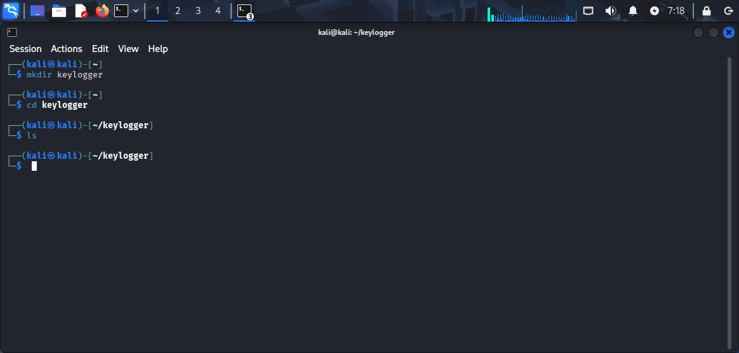

Overview
This screenshot shows the initial setup phase of the Python keylogger project, where the development environment and project directory are created using the Linux terminal in Kali Linux. This step is essential for organizing project files and maintaining a clean workspace during development.

Operating Environment
- Operating System: Kali Linux
- Interface: Linux Terminal (Shell)
Kali Linux is widely used for cybersecurity, ethical hacking, and security research, making it suitable for learning and testing security-related tools in a controlled environment.

Commands Used and Their Purpose
mkdir keylogger
This command creates a new directory named keylogger. Purpose:
To store all source code, scripts, and related files of the project in one dedicated folder.
Helps in maintaining modularity and proper file management.
cd keylogger
Changes the current working directory to the newly created keylogger folder.Purpose:
Ensures that all further development work (code creation, virtual environment, scripts) happens inside the project directory.
ls
Lists the contents of the current directory.
Since the directory is newly created, it appears empty.Purpose:
To verify that the directory exists and is ready for use.

Importance of This Step
- Establishes a structured development workflow.
- Prevents mixing project files with system or unrelated files.
- Makes debugging, testing, and report documentation easier.
- Reflects professional software development practices, which are expected in an internship or corporate environment.

Python Virtual Environment Setup

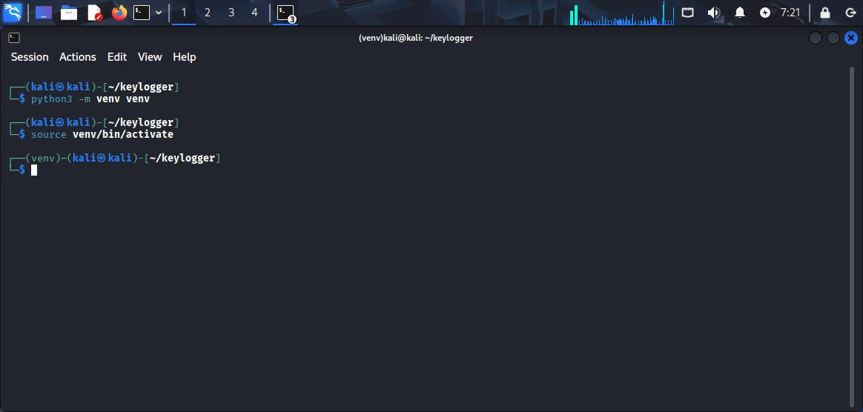

Overview
This screenshot demonstrates the creation and activation of a Python virtual environment for the keylogger project. A virtual environment is an isolated workspace that allows Python projects to manage their dependencies independently from the system-wide Python installation.

Commands Used and Explanation

1. python3 -m venv venv
- This command creates a virtual environment named venv inside the project directory.
- The venv module is a standard Python tool used to create lightweight, isolated environments.
- Purpose:
  - To avoid dependency conflicts with other Python projects
  - To ensure consistent library versions
  - To maintain a clean and controlled development setup
After execution, a venv directory is created containing:
- A private Python interpreter
- Package management tools (pip)
- Required activation scripts

2. source venv/bin/activate
- This command activates the virtual environment.
- Once activated, the terminal prompt changes and displays (venv) at the beginning.
- Purpose:
  - Ensures all Python packages installed afterward are limited to this project
  - Guarantees that the project runs using the correct Python environment

Installation of Required Python Libraries for Keylogging
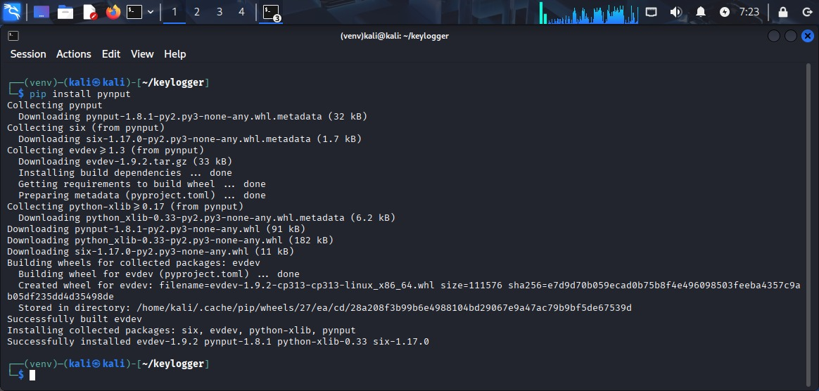
This screenshot demonstrates the installation of the required Python library pynput inside a virtual environment on Kali Linux. The pip install pynput command is used to install external dependencies necessary for capturing keyboard input at the operating system level.

Purpose of Using pynput
The pynput library is a high-level Python module that allows monitoring and controlling input devices such as the keyboard and mouse. In this project, it is used to listen for keyboard events in order to understand how keystroke capturing works from a defensive and educational cybersecurity perspective.

Virtual Environment Usage
The (venv) prefix in the terminal indicates that a Python virtual environment is being used. This ensures:
- Isolation of project dependencies
- Avoidance of conflicts with system-wide Python packages
- Better project maintainability and security
Using virtual environments is considered a best practice in professional software development and cybersecurity projects.

Dependency Breakdown
During the installation process, several supporting libraries are automatically downloaded and installed:
- pynput – Core library responsible for keyboard and mouse event listening
- evdev – Enables low-level input event handling on Linux systems
- python-xlib – Provides interaction with the X Window System (used for graphical input capture)
- six – Ensures compatibility between Python 2 and Python 3
These dependencies allow the program to interface with the operating system’s input subsystem in a controlled manner.

Successful Installation Confirmation
The message “Successfully installed …” confirms that all required packages have been installed correctly. This indicates that the environment is now fully prepared to execute the keylogging simulation code without dependency-related errors.

Basic Keylogging Logic Using Python
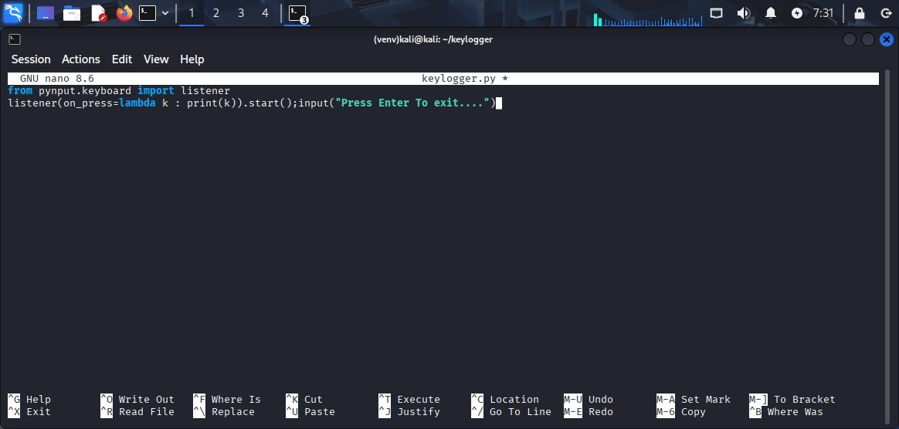
This screenshot shows the implementation of a basic keyboard event listener written in Python using the pynput library. The code is edited using the Nano text editor on a Kali Linux system.

Importing the Keyboard Listener Module
The program begins by importing the listener module from pynput.keyboard. This module provides functionality to monitor keyboard events such as key presses and releases at the operating system level.
This abstraction allows the program to interact with keyboard input without directly accessing hardware, making it suitable for educational simulations and controlled environments.

Keyboard Event Listening Mechanism
The listener is configured to monitor key press events. Whenever a key is pressed, the listener captures the event and triggers a predefined action. In this implementation, the captured keystroke is displayed on the terminal output.
This demonstrates how keystroke logging mechanisms work conceptually by:

- Intercepting keyboard input
- Processing the input in real time
- Displaying or storing the captured data
Such mechanisms are often analyzed in cybersecurity to understand how malicious keyloggers operate and how they can be detected or prevented.

Lambda Function Usage
A lambda function is used to define a simple, inline callback action that executes whenever a key is pressed. This approach allows concise handling of keyboard events without the need for a separate function definition.

Listener Execution and Control
The listener runs continuously in the background once started. The program includes a user prompt that keeps execution active until manual termination. This ensures the listener does not stop immediately and continues monitoring keyboard activity during runtime.
Press ctrl + O and Enter THEN ctrl + X to save

Execution and Output of the Keylogging Program
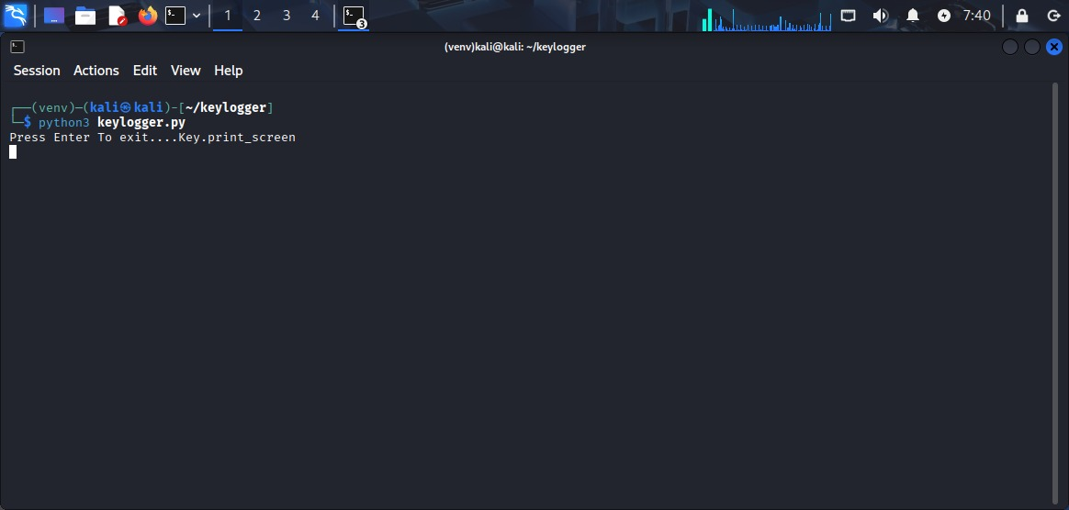
This screenshot illustrates the successful execution of the Python-based keylogging simulation using the command python3 keylogger.py within a virtual environment on Kali Linux.

Program Execution
The command initiates the keylogging script, indicating that:
- All required dependencies are correctly installed
- The Python environment is properly configured
- The script is free from syntax or runtime errors The absence of error messages confirms that the program is running as expected.

Runtime Behavior
Once executed, the program enters an active listening state and begins monitoring keyboard input in real time. The message displayed on the terminal prompts the user that the application is currently running and provides an option to terminate execution manually.
As keys are pressed, the program captures the keystroke events and displays them on the terminal. In this screenshot, a special key press event (Key.print_screen) is shown, demonstrating that the listener is capable of detecting both:

Keylogger Execution and Output

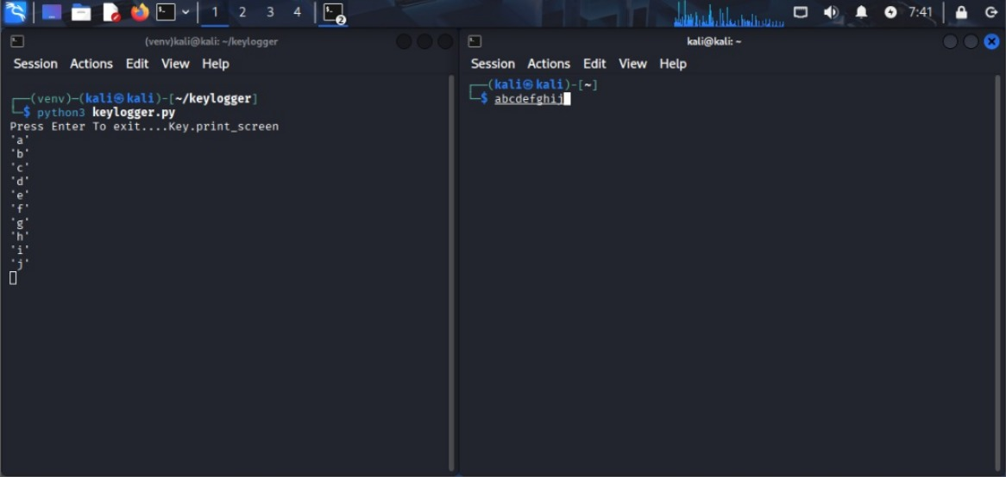

Overview
The screenshot demonstrates the execution and real-time operation of a host-based keylogging application in a controlled Linux environment (Kali Linux). The system is shown using two terminal windows to validate the functionality of the keylogger by comparing user keystroke input with captured output.

Environment Description
- Operating System: Kali Linux
- Execution Context: Python virtual environment
- Application: Custom-developed keylogger script
- Interface: Terminal-based (CLI)
The left terminal is used to execute the keylogger program, while the right terminal simulates user input activity.

Functional Working Principle: A keylogger is a system-level monitoring tool designed to capture keyboard events generated by the operating system. Once executed, it registers a listener that continuously monitors keypress events until termination.
- The keylogger script is launched using the Python interpreter.
- Upon execution, the program enters an active listening state, indicated by a prompt message instructing the user how to exit the program.
- As keystrokes are entered in the second terminal window, each keypress is captured and logged in real time.
- The captured characters are displayed sequentially in the keylogger’s output terminal, demonstrating successful interception of keyboard input.

Observed Behavior
- Each alphabetic key pressed in the right terminal (a through j) is immediately reflected in the left terminal.
- The output confirms that the keylogger correctly:
  - Detects individual keystrokes
  - Processes them sequentially
  - Displays or records them without data loss
- The application continues running until a specific termination condition is met (e.g., pressing Enter)

Description of the Execution Scenario

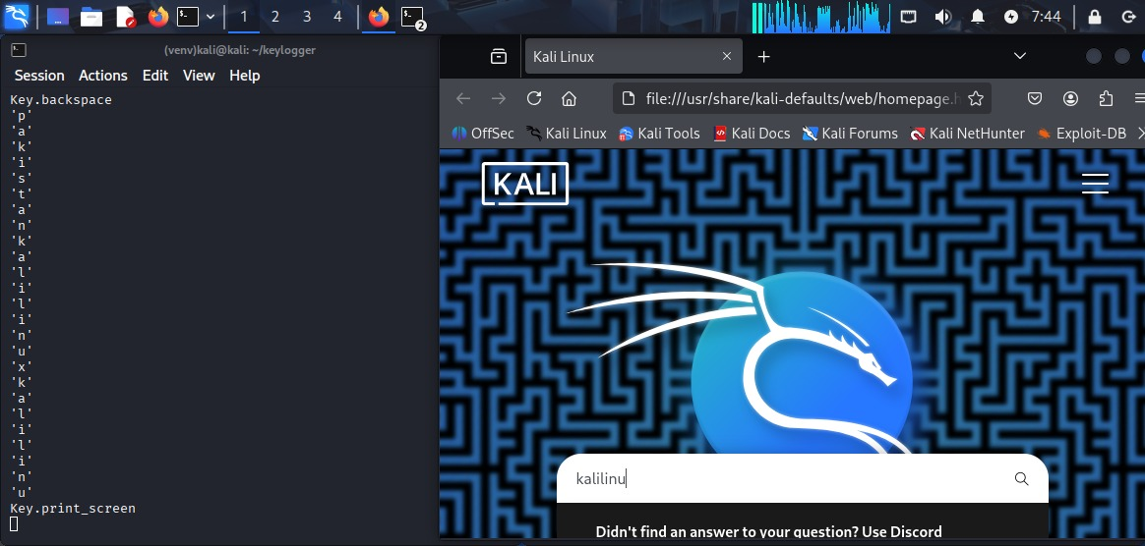
The system is shown with:
- Left Panel: Terminal window displaying keylogger output
- Right Panel: A graphical web browser (Kali Linux default homepage) used as an input source
Unlike the previous scenario where keystrokes were entered in a terminal, this setup validates that the keylogger operates globally across applications, including GUI-based programs.
Captured Input Analysis
The output terminal shows:
- Printable characters (e.g., k, a, l, i, n, u, x)
- Special keys, represented symbolically:
  - Key.backspace → indicates detection of deletion events
  - Key.print_screen → indicates detection of system-level shortcut keys
This confirms that the keylogger does not merely log visible characters but also captures non-printable control keys, which are crucial for accurately reconstructing user input behavior.

Limitations of KEYLOGGER
- Captures only keyboard input; does not include mouse or clipboard data
- Terminal-based output limits usability for long-term logging
- Requires appropriate permissions to function correctly
- Not suitable for real-world deployment without ethical and legal safeguards
- The output is raw and sequential, requiring post-processing for context reconstruction
- No differentiation between benign and sensitive input
- No encryption or secure storage mechanism for logged data
- Intended strictly for controlled and authorized environments

Conclusion
This screenshot demonstrates the keylogger’s ability to capture both printable and special keyboard events across multiple application types, including graphical interfaces. The results confirm effective system-wide input monitoring and provide valuable insight into how keyboard events propagate through an operating system. Such experiments are essential for understanding both offensive techniques and defensive security design.

